The Red One Camera. Through the Crosshairs of my Eyepiece: Is This Big Deal the Real Deal?

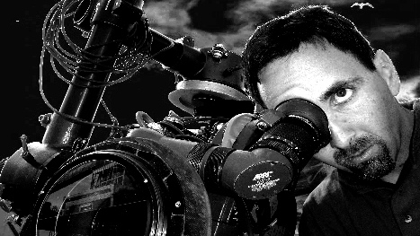
By Cinematographer Daron Keet | March 10, 2009

Here are my thoughts about the Red One camera’s ability to stand up to the plate in delivering images I would expect from 35mm negative film.
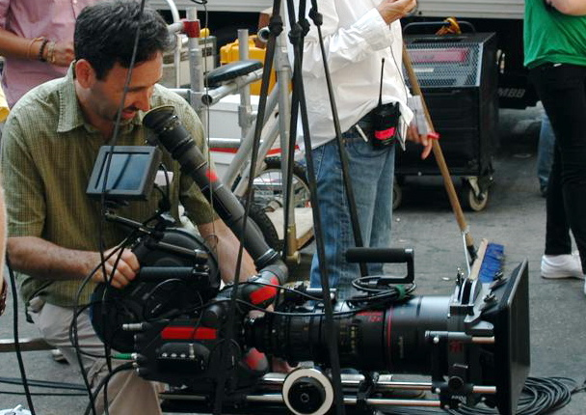
Are 35mm film cameras’ days numbered?
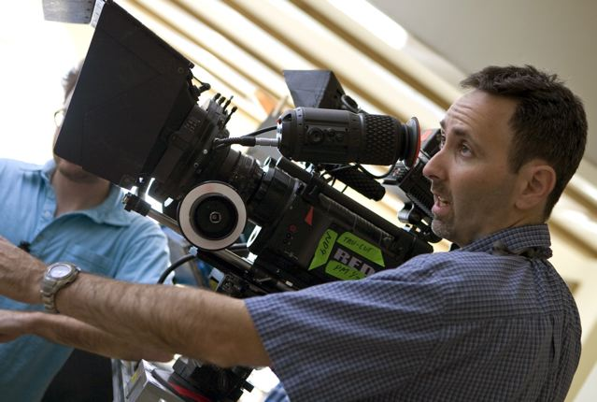
Are Red cameras’ days only beginning?

Before I begin, I must confess I walk out of banks if they have long lines, and walk out of movie theatres if the middle row seats toward the back are taken. What relevance does this have to the Red you ask? Everything—considering we carry our personal traits into our every decision. In my case I am impatient and strive to work quickly, and as a visually motivated cinematographer I do not want to compromise when it comes to watching films, and by extension do not compromise when it comes to making films.
With my character traits revealed, here is how I see it through the crosshairs of my eyepiece. To begin with, the Red One is not a film or HD camera; it is like a large digital SLR camera, except it captures metadata at 24-30fps at 4k, 60fps at 3k, and up to 120fps in 2k resolution.
Filmmakers who consider their work art had better become technicians fast if they intend using the Red One, as it does not have the color palette tool in the creation of the nuanced finessed brushstrokes you are accustomed to getting from film. You simply cannot be green if you want to go Red. The Red One currently uses a CMOS digital sensor capturing images at 4520k pixels of resolution by 2540k pixels of resolution. It is retrofitted with a film PL mount, which means its digital sensor is able to gather light, utilizing and taking advantage of the finest optical quality film lenses ever made. This gives the Red the equivalent characteristics of 35mm film’s narrow depth of field in terms of focus.
The most exciting aspect of Red One technology is that it enables you to watch and approve dailies instantly, whereas film needs to be processed and scanned in order to be outputted and viewed. Furthermore, the Red One’s proprietary hard drives allow up to 3-hour takes compared with 10-minute takes in traditional film. Without a doubt the Red One’s tapeless workflow acquisition is unparalleled in facilitating post-production schedules and budgets, but at what cost visually?
On film shoots you are able to overexpose your negative, blow out the highlights and recover them later. Personally, I overexpose film negative by two-thirds of a stop in order to get a thicker negative, in other words more image information. There is an assumption that with Red One the look is not “baked” into the raw files when you shoot, and that with color correction software you have infinite information to manipulate. Not true. The Red One is not immune to digital exposure rules and it has a hard floor for the blacks and a hard ceiling for the whites. If you blow out the pixels on a Red One digital sensor they will “hard clip,” leaving you with no image information to manipulate. The reason digital cameras have limited exposure latitude is that they capture information in a linear color range space, as opposed to film which captures information in a logarithmic color range space. The human eye perceives contrast, light and detail logarithmically, so it is no surprise audiences still have a natural disposition toward a “filmic” versus “digital” look so deep into our digital generation. In defense of the Red One I will say its wavelet compression and 12-bit color space do hold highlights in a fairly pleasing and organic manner for a digital camera, but nothing has ever compared to the controlled and pleasing manner negative film’s highlights roll over the exposure curve.
So here’s the rub: On digital cameras many filmmakers skew toward slight underexposure in order to preserve highlights. Although underexposure in the digital world is a fantastic technique for both protecting whites and achieving great-looking velvety blacks, this is not the case with the Red One. When you underexpose the Red One you essentially waste linear bits of metadata the camera could have captured. When you open up underexposed Red One footage in the raw conversion, you end up with digital noise, milky blacks and posterization. Posterization is the undesirable concept of spreading too little continuous information too far apart in a digital camera’s linear range, resulting in bands that run across the image, particularly at the points when two colors without sufficient tonal information meet.
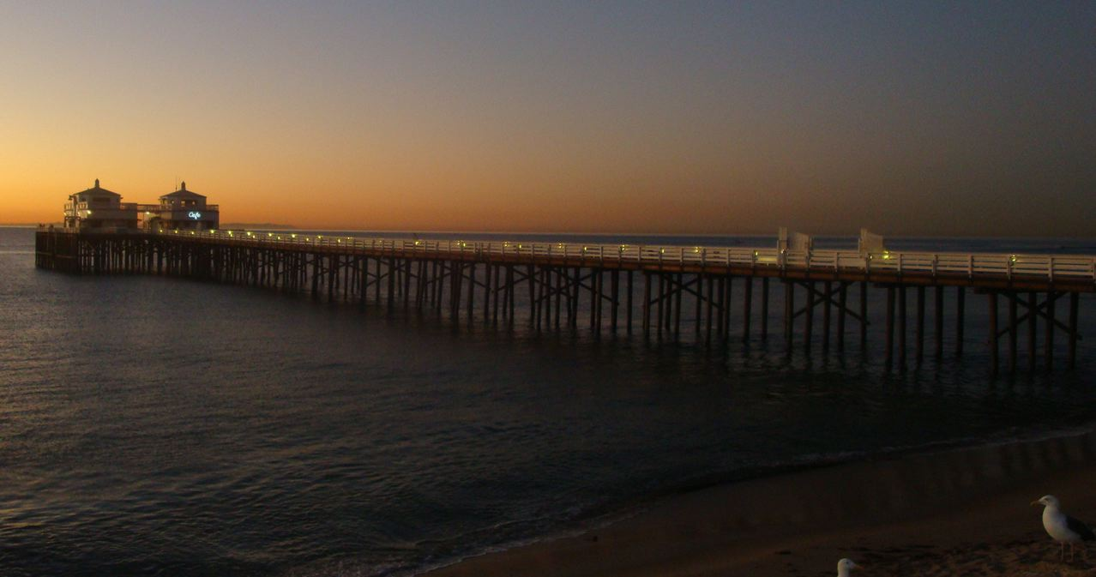An example of digital posterization above shows more digital noise on the right, which lacks exposure, versus the left side, which has more exposure, therefore more information for a digital sensor’s linear range.
So what is the solution to nailing exposure on the Red One?
* I begin the process with my old, trusted light meter, then use the Red One’s many digital modes to help fine-tune the camera’s proverbial sweet-spot exposure, in order to capture the cleanest digital image possible.
* I expose precisely at the Red One manufacturer’s recommended 320 ASA index rating for its sensor.
* I then set my light meter to 320 ASA and determine my T-stop via digital exposure rules, primarily exposing for my key light.
* I access the histogram mode on the Red One monitor to determine whether my exposure has placed highlights as close to the right side of the histogram as possible. Exposing to the right is the single most important trick to ensuring you have no digital noise contamination in the mid-tones and shadows. If nothing touches the right side of the histogram, I ignore my pre-determined light meter’s reading, and open up the lens T-stop until the values move as far over to the right as possible without having clip issues.
* With my lens T-stop now determined, I get out my light meter to check my key to fill light ratio. For the most dramatic scene requiring the fullest tonal exposure range from pure whites to pure blacks, I expose with my fill light exactly two-and-three-quarters of a stop under my chosen T-stop. This creates the precise amount of detail I require for Red One linear exposure range, ensuring I have great- looking blacks in my shadows and detailed, pure unclipped whites in my highlights.
* I check my exposure one last time by activating the Red One’s false color mode to make sure no important information I require is pink. Any pink color in this mode tells me I am overexposing the Red One sensor. At this point if I see pink I will not adjust my camera lens T-stop, but use grip gear or graduated filters to bring back the overexposed areas into acceptable exposure zones.
* In my experience any Red One build 16 or onwards has a noise floor that is vastly improved over Red One build 15, so it’s a no-brainer that you should upgrade. 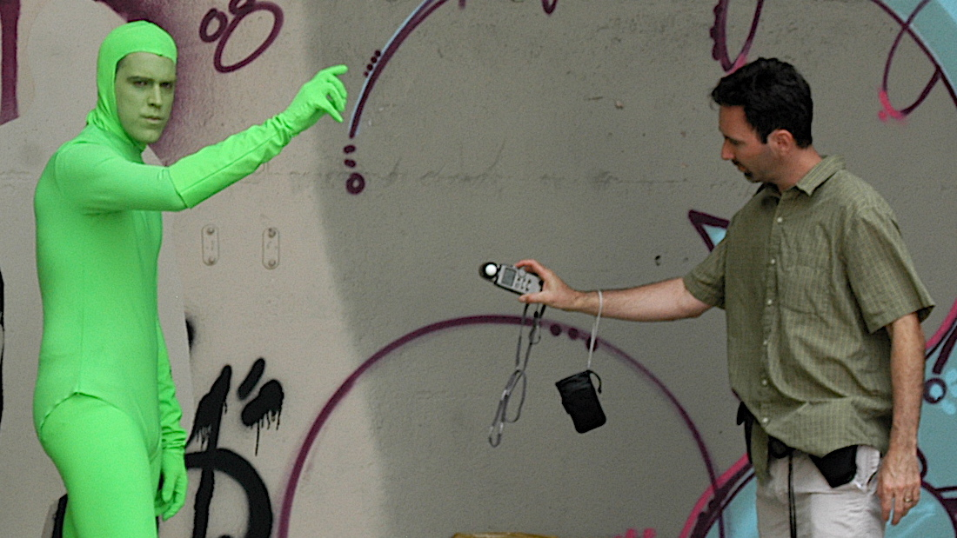On either digital or film shoots I use an incident light meter to determine lighting ratios.
The Red One has a sensor balanced to 5000 Kelvin daylight. This is an important point to grasp because the sensor captures the cleanest images under daylight sources. This does not mean you can’t shoot the Red One in tungsten mode, but if you do you are more susceptible to getting digital noise as you have not activated the Red One sensor’s blue channel. To activate the blue channel while in tungsten mode, you can introduce a blue backlight. However, having to resort to using blue light in a warm, motivated tungsten scene to avoid potential digital noise is aesthetically ridiculous. Technology needs to propel us forward, not hold us back. The Red One sensor’s bias to daylight is without a doubt my single biggest peeve about it. Further exacerbating my gripe, while traditional daylight film stocks and daylight lights measure 5600 Kelvin, the Red One chose a sensor balanced to 5000 Kelvin. I can’t fathom why, however my task is not to question and complain, but rather to find solutions and solve.
Above image: Red Camera, Rated 320 ASA, Daylight setting, 85mm Zeiss lens.
Because the Red sensor is balanced to 5000 degrees Kelvin it renders the sky deep blue.
Above image: Arriflex 435 35mm camera, 250 ASA Daylight Kodak film stock, 85mm Zeiss lens.
Because daylight-balanced film stock is 5600 degrees Kelvin, the sky is rendered closer to the color blue your eye sees.
In response to the Red One sensor’s bias issues, I add 1/4 Color Temperature Orange (CTO) gels to my HMI’s daylight lights and carry 81 series filters to help balance the color temperature as needed. As a side note for filmmakers who are fans of daylight-balanced fluorescent and LED lights, you are in fine shape as those sources - like the Red One - are balanced to 5000K exactly. The 81a filter converts 5600K to 5000K with one-third of a stop loss; the 81ef converts 7500K to 5000K with two-thirds of a stop loss. These filters are very useful when shooting with the Red One as I find the camera’s sensor moves blue toward the purple spectrum for some reason, when the color temperature increases from 7000K to 11000K.

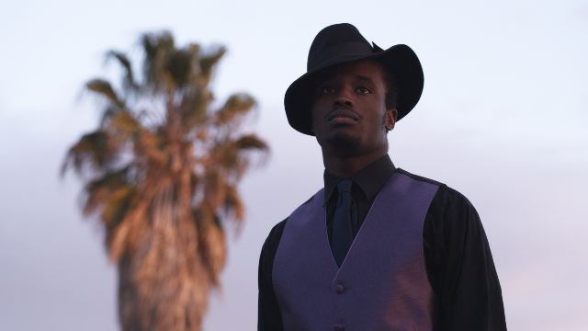
Notice how the above Red-captured image moves toward the purple spectrum as color temperature increases above 7000 degrees Kelvin.

When shooting with the Red One I am not scared to stack filters up to control exposure and enhance in-camera images as I desire. I use polarizers to saturate skies or control reflections when shooting at angles through glass or water. I use graduated neutral-density (ND) filters to control exposure. I use straight neutral-density (ND) filters to reduce the amount of light hitting the sensor, thus allowing a larger aperture to create shallow depth of field. But be careful because multi-stop neutral-density (ND) filters exacerbate the Red One camera’s sensitivity to light in the IR spectrum, which though not visible to the human eye can result in color shifts and prevent capturing of true blacks. To help prevent this oddity when using neutral-density (ND) filters on the Red One, I use NDs in conjunction with a Tru-Cut IR-750 filter, which corrects the potential for color shifts.
As a cinematographer who likes to move quickly, both film and Red One take up about equal time on set. Film has loading time issues, Red One has battery changing time issues. Red One can capture longer takes than film, but more footage invariably takes more time to shoot and review, so timewise both formats cancel each other out.
Interestingly enough, my lighting and grips package for a Red One would be the same as a film shoot requiring 320 ASA stock. However, I do concede that with regard post-production, there is no doubt the Red One is the most exciting tapeless workflow acquisition camera around. It is going to revolutionize the speed in which we move through post.
To capture high-quality day exterior images whether shooting digital or film requires the same amount of gear to control exposure.
To capture high-quality night interior images whether shooting digital or film requires the same amount of gear to control exposure.

In conclusion, I don’t think the Red One is a compromise - I think it is merely another professional tool we ought to embrace and enthusiastically add to our repertoire. For a linear-capturing digital camera it is no slouch. It is capable of capturing beautiful images, which ultimately and always are in the eye of the beholder, our audience. The biggest difference between shooting film and shooting with the Red One is still the way the two media respond to capturing light. And no matter what the future holds for film, we should always remember that film responds to light the same way our eyes do.
Daron's cinematography can be viewed at www.daronkeet.com

